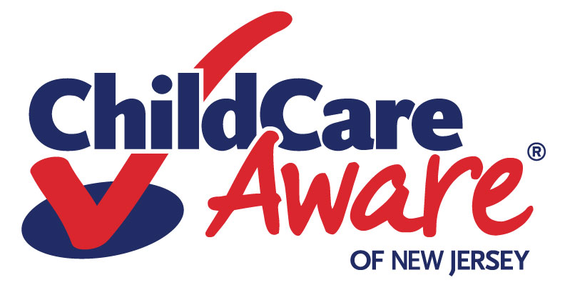
Checklist for Family Child Care Registration Certificate Applicants
August 2022

Documents Required | Completed
2 Reference forms for Provider
2 Reference forms for Alternate Provider (if any)
Physician’s statements (health exam forms)
Provider
Substitute
Assistant or Alternate (if any)
Household members 14 years of age and older
Household members under 14 years of age
Tuberculosis test form
Provider
Assistant or Alternate (if any)
Household members 14 years of age and older
Fingerprints
Provider
Substitute
Assistant or Alternate (if any)
Household members 18 years of age and older
Child Abuse Record Information and Criminal Conviction Disclosures
Provider
Substitute
Assistant or Alternate (if any)
Household members 14 years of age and older
Proof of current pet vaccination(s) documented by a veterinarian (if applicable)
Current Cardiopulmonary Resuscitation (CPR) certification and first aid
Provider
Substitute
Assistant or Alternate (if any)
CCDBG Required Trainings – Provider, All staff and Alternates
2 hours -- orientation
10 hours -- Health & Safety, Child Development, Mandated Reporter-Child Abuse/Neglect
6 hours -- CPR/First Aid
Note: A registration certificate covers a 3-year period and must be renewed. Both initial registration and renewal require a $25 fee (check or money order to the sponsoring organization).


