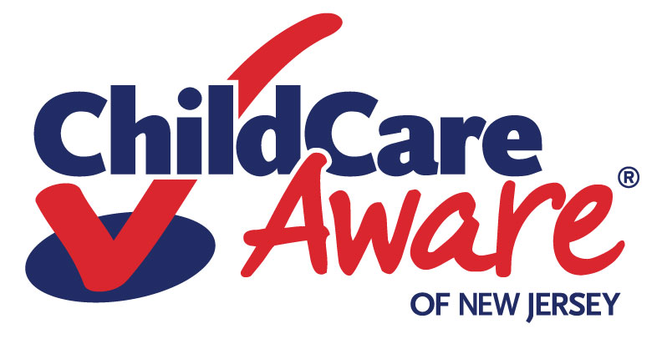

Checklist for Family Child Care Registration Certificate Renewal
August 2022

Documents Required | Completed
Physician’s statements (heath exam forms)
Provider
Substitute
Assistant or Alternate (if any)
Household members 14 years of age and older
Household members under 14 years of age
Child Abuse Record Information (CARI) and Criminal Conviction Disclosure
Provider
Substitute
Assistant or Alternate (if any)
Household members 14 years of age and older
Proof of current pet vaccination(s) documented by a veterinarian (if applicable)
Current Cardiopulmonary Resuscitation (CPR) certification and first aid
Provider
Substitute
Assistant or Alternate (if any)
Professional Development
Documentation of attendance at 20 hours of in-service training (other than CPR and first aid) during the past 3 years after you have received your registration certificate)
Provider
All staff and alternates
Note: A registration certificate covers a 3-year period and must be renewed. Both initial registration and renewal require a $25 fee (check or money order to the sponsoring organization).


